**ExperimentNo :-1**

**Name :- Rahul Maurya UID:- 20BCS7260**

**Subject :- PBLJ**

**Aim :-**Create a application to save the employee information using arrays.

**S/W Requirement:-**Eclipse_IDE - (Java),Netbean..

**Source Code :-**

**package** Exp;

**publicclass**Arremp {

**publicstaticvoid**main(String[] args) {

**int**empno[] = {1001,1002,1003,1004,1005,1006,1007};

String name[]={"Ashish","Sushma","Rahul","Chahat","Ranjan","Suman","Tanmay"};

StringJoinDate[]={"01/04/2009","23/08/2012","12/11/2008","29/01/2013","16/07/2005","1/1/2000","12/06/2006"};

**char**d_code [] = {'e','c','k','r','m','e','c'};

String dept[]={"R&D","PM","Acct","front","Desk","Engg","Manufacturing","PM"};

**int**basic [] = {20000,30000,10000,12000,50000,23000,29000};

**int**hra [] = {8000,12000,8000,6000,20000,9000,12000};

**int**it [] = {3000,9000,1000,2000,20000,4400,10000};

String designation = **null**;

**int**da=0;

**int**salary = 0;

**int**index = -1;

**int**emp= Integer.*parseInt*(args[0]);

**for**(**int**i=0;i<empno.length;i++)

{

**if** (empno[i]==emp)

{

index=i;

}

}

**if** (index==-1)

{

System.***out***.println("There is no such employee." +emp);

}

**else**

{

**char**code;

code=d_code[index];

**switch**(code)

{

**case**'e':

designation="Engineer";

da=20000;

**break**;

**case**'c':

designation="Consultant";

da=32000;

**break**;

**case**'k':

designation="Clerk";

da=12000;

**break**;

**case**'r':

designation="Receptonist";

da=15000;

**break**;

**case**'m':

designation="Manager";

da=40000;

**break**;

**default**:

designation="Invalid";

da=0;

}

salary=basic[index]+ hra[index]+da-it[index];

System.***out***.println("Emp No" +" "+"Emp Name" +" "+"Department"+" "+"Designation"+" "+"Salary");

System.***out***.println(empno[index]+" "+name[index]+" "+dept[index] +" "+designation +" "+salary);

}

}

}

**Input :-**

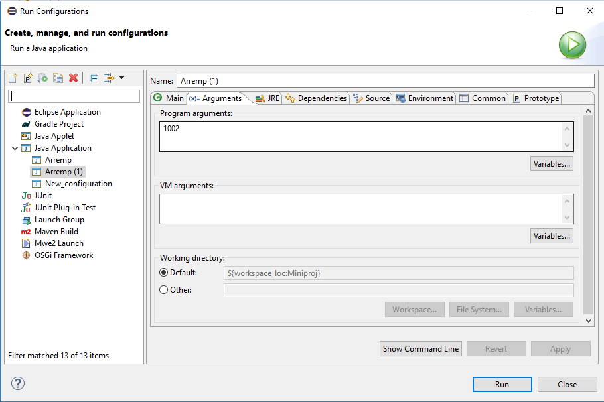

**Output :-**



